Module 3: Critical Thinking Assignment

Nathan Rogers
Colorado State University Global
Course Code: CSC505
Dr. Luis Gonzalez
03/02/2025

Assignment
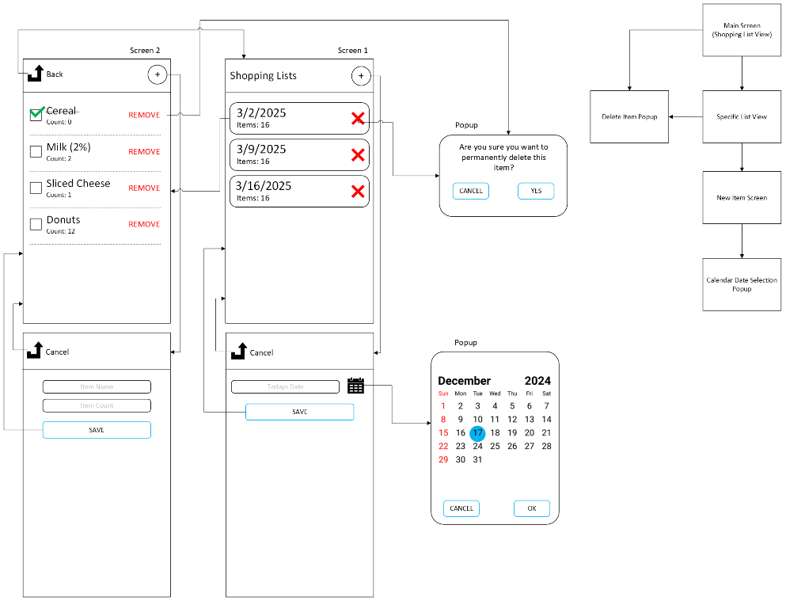
You have been contacted and are thinking about developing a "first" prototype for a mobile app that lets users save a shopping list on their devices. How would you create a preliminary architectural design for it? Choose the necessary tools (UML or other diagramming tools) to show your strategy. Then create a series of sketches representing the key screens for a paper prototype for the shopping list app. Use Python to write a script that will print out the names and number of pages in your prototype and the sequence or flow of the pages.

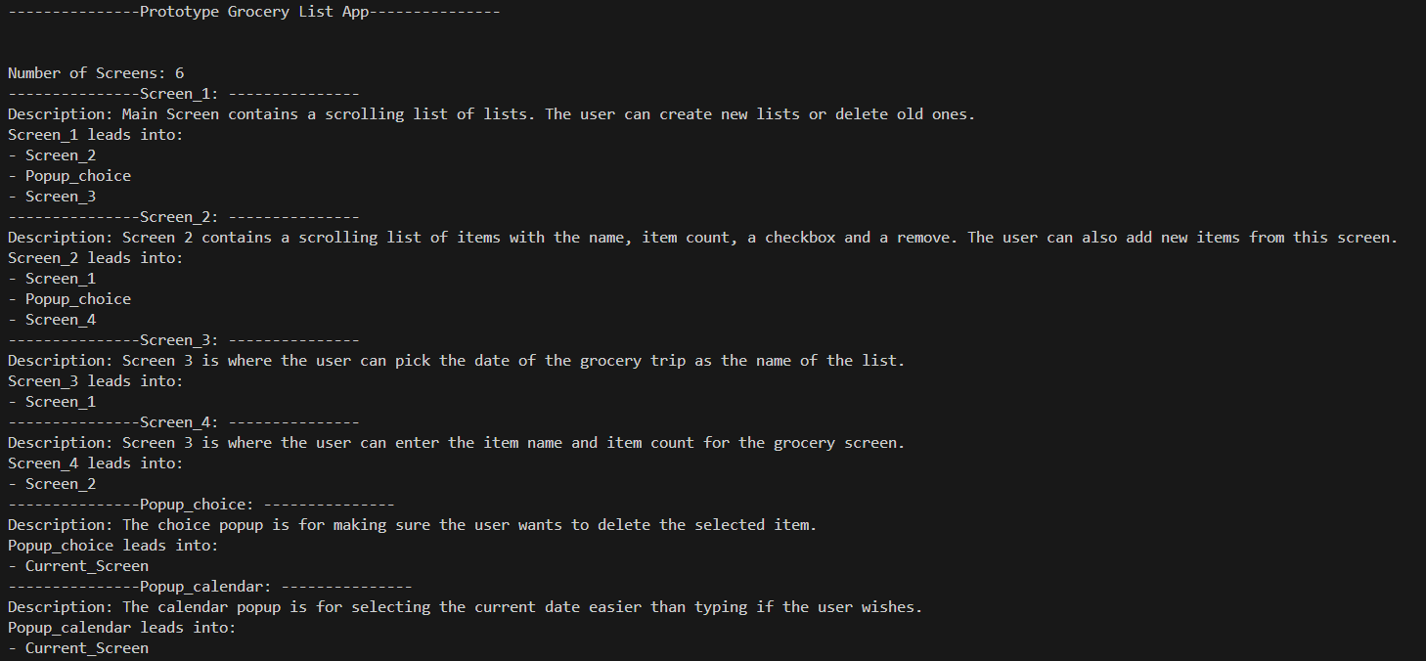
Screen_4 Screen_3

Prototyping
Prototyping is a very important step in the development process. This stage helps the developing company and stakeholders decide if the project is a viable one to be successful and profitable. “However, the type and quality of a prototype can influence how stakeholders perceive a new design concept and can, therefore, impact their responses.” (Deininger et al., 2019). Therefore, it is important to provide a good representation of the end software and as important to do so quickly/as early on as possible.
Prototyping is very useful when a full project with a complete set of requirements hasn’t been made yet. This paradigm allows for testing to see what is possible algorithm-wise or to see the basics of a user interface that can be refined later based on stakeholder or end user feedback. “Ideally, the prototype serves as a mechanism for identifying software requirements. If a working prototype is to be built, you can make use of existing program fragments or apply tools that enable working programs to be generated quickly.” (Pressman & Maxim, 2020)
If the prototype is distributed for internal testing, a method of gathering user data could be having the testers submit GitHub issues for: “What works well?”, “What needs changed?”, “Is this app idea worth pursuing?”, to gain a well-rounded idea of what the testers thought of the prototype. If the prototype is distributed in an open-beta format, you could gather user feedback through popups in the apps asking for feedback on the prototype. This does leave it up to the tester to provide those details, which some people may not. Developers may also choose to implement crashlytics or error reporting to gather system issues additionally to user feedback.
It is important to keep in mind that while prototyping can be a helpful and worthwhile investment, directly jumping into the project from this point can be a hinderance. At the time of prototyping no documentation or requirements have been made for the project so it’s important to take a step back after a successful prototype stage and assess what still needs to be completed before full development can take place. Its also important that the “quick and dirty” code that was used to produce the working prototype is not used in the final build of the project. It’s ideally best to go back and clean up the UI code and backend algorithms before they become an integral part of the project. Messy and unorganized code can lead to issues bringing on new developers and refactoring later on when new features require changes to older code.
Using the above mockup, we could make this a real prototype in languages such as Kotlin for Android, swift for iOS, or flutter and dart for a single codebase that compiles into both native Kotlin and JavaScript for Android and native swift for iOS. With the end-goal in mind to develop for both platforms I would personally develop this prototype in flutter and dart. This would allow for a quickly made and working, semi-polished prototype for further stakeholder testing. This language also allows for easy, real-time adjustment making so implementing any feedback from the prototype testing phase would be easy and straightforward.
My company, Runtime Entertainment, launched an application for hosting trivia nights in restaurants. We built a quick and rough first iteration and got users feedback both internal and external to RTE. We got extremely valuable user feedback such as broken features, new features that would benefit users, and application runtime issues, all which were expected. All of the user feedback allowed us to take steps to improve and implement new features that improved the overall user experience.
References
Pressman, R. S., & Maxim, B. R. (2020). Software engineering: A practitioner’s approach. McGraw-Hill Education.
Cooprider, J. G., & Henderson, J. C. (1990). Technology–process fit: Perspectives on Achieving Prototyping Effectiveness. Journal of Management Information Systems, 7(3), 67–87. https://doi.org/10.1080/07421222.1990.11517897
Deininger, M., Daly, S. R., Lee, J. C., Seifert, C. M., & Sienko, K. H. (2019). Prototyping for context: exploring stakeholder feedback based on prototype type, stakeholder group and question type. Research in Engineering Design | Springer. https://doi.org/10.1007/s00163-019-00317-5

